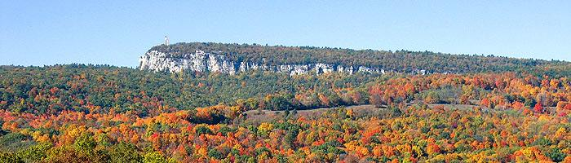

**CARING FOR CREATION**

**WHAT WE'VE DONE SO FAR**

* Sponsored a community wide annual Earth Day Fair since 2002, that attracts hundreds of contributors and visitors and brings together environmentally friendly organizations.

*Initiated energy audits of our four buildings by NYSERDA and followed up with many of their recommendations. *Raised money and contributed seed funding for several energy-saving purchases.

*Explored and continue to advocate for solar energy for the church.

*Discontinued the use of Styrofoam cups, and encourage the use of only ceramic/glass/recyclable/compostable products for all events.

*Use environmental friendly cleaning products.

*Use recycled paper products for all office and educational purposes.

*Use only Fair Trade coffee at all church events.

*Added a compost bin for coffee grounds and other waste.

*Host environmental speakers and events.

**We welcome new members as we look to expand our efforts.**

**Please contact us if you are interested!**

Cheryl Alloway, [cherylalloway@gmail.com](mailto:cherylalloway@gmail.com)   Judy Elliot, [judyelliot46@gmail.com](mailto:judyelliot46@gmail.com)

Janet and Jim O'Dowd, jimmyodowd@yahoo.com

Adriana Havnaer, [adrianahavnaer@gmail.com](mailto:adrianahavnaer@gmail.com)

**A BIT OF HISTORY**

The Caring for Creation (C4C) Committee was formed in 2002 and grew out of an awareness of the escalation of world-wide environmental degradation.  The mounting scientific evidence concerning climate change also brought with it the realization that we are facing a threat to our home, our planet and God’s creation.  Carelessness, short sightedness and outright greed had gotten us into this crisis.  Hopefully a religious and spiritual perspective provides the moral force to help get us out of it.

In 2008 the Consistory supported and approved a “Green Policy” and the designation, “We are a Green Church.” RCNP strives to make decisions guided by this policy.  Our goal and responsibility is to educate and support good environmental actions in all aspects of church and individual life.